Homework 6
- Conjunctive normal form is useful in automated logical reasoning firstly because having a standard format for a system is key. It helps when having to deal with any sort of complex expressions. One inference algorithm that uses CNF is Resolution - once everything is CNF, it is proved that if the knowledge base entails something (a), the resolution knowledge base or not a derives the empty clause.
- Syntax is the structure of the sentence, the formatting of it. Syntactical component of this logic sentence are P, Q, R (symbols), connectives, grouping. Semantics are more about meaning, the overall message or understanding of a logic sentence. In this case semantics are the truth value of P ^ Q and its applications.
- 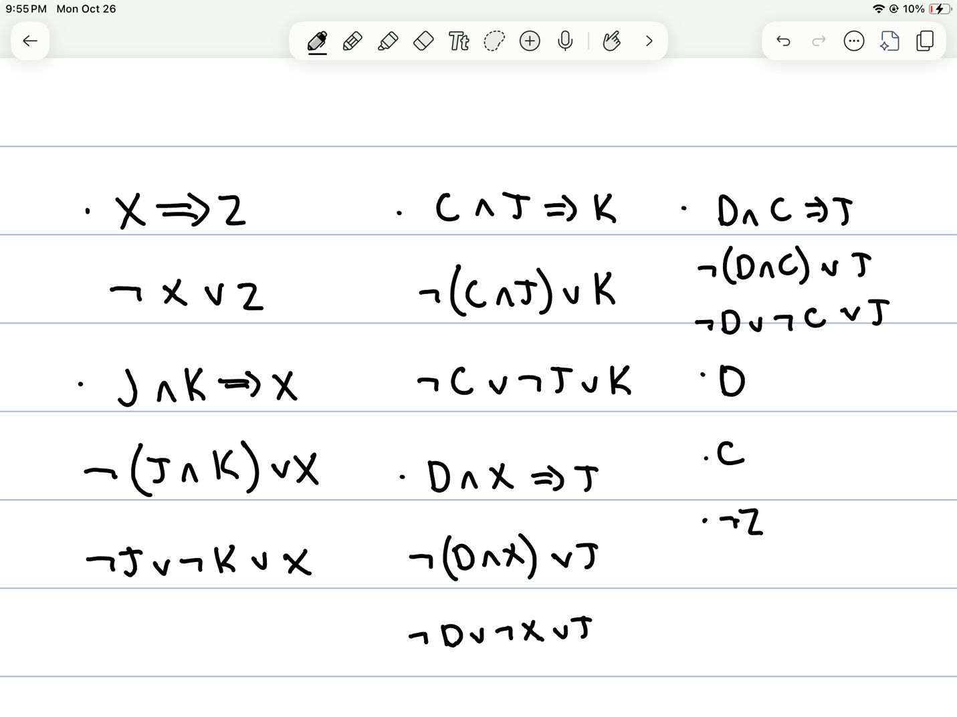

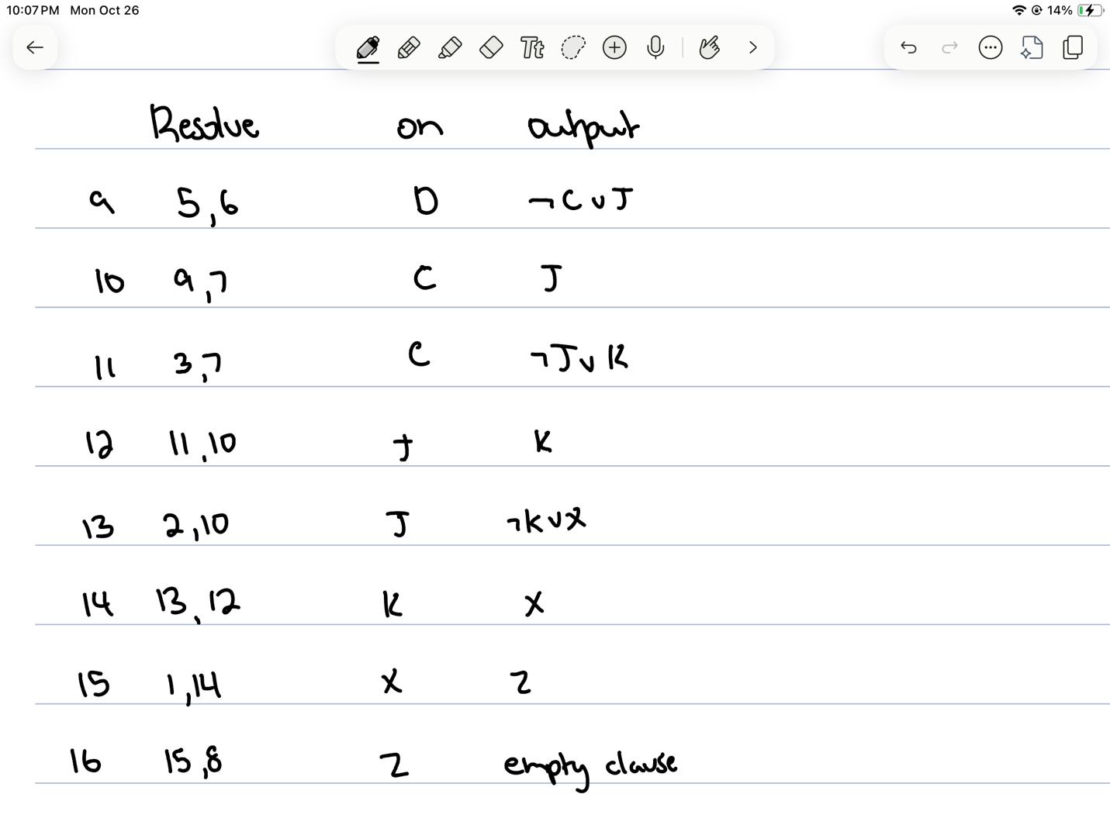
- 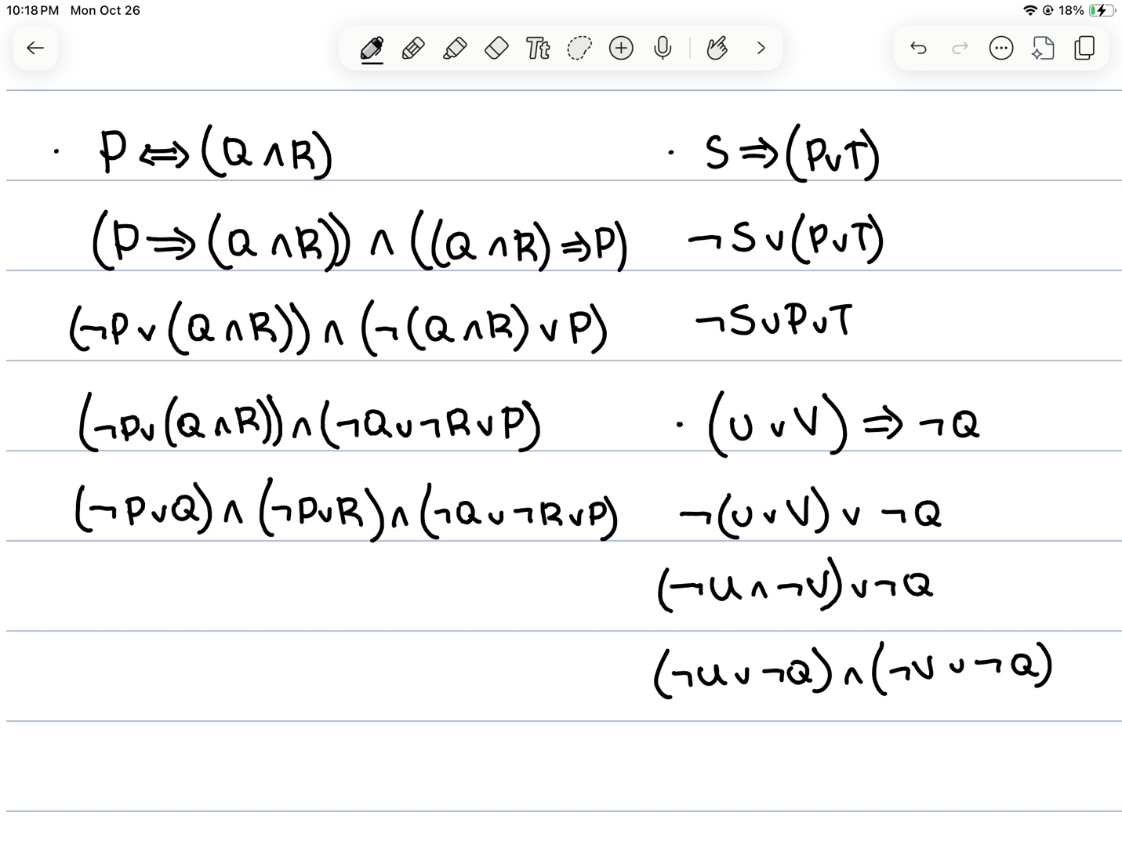

- 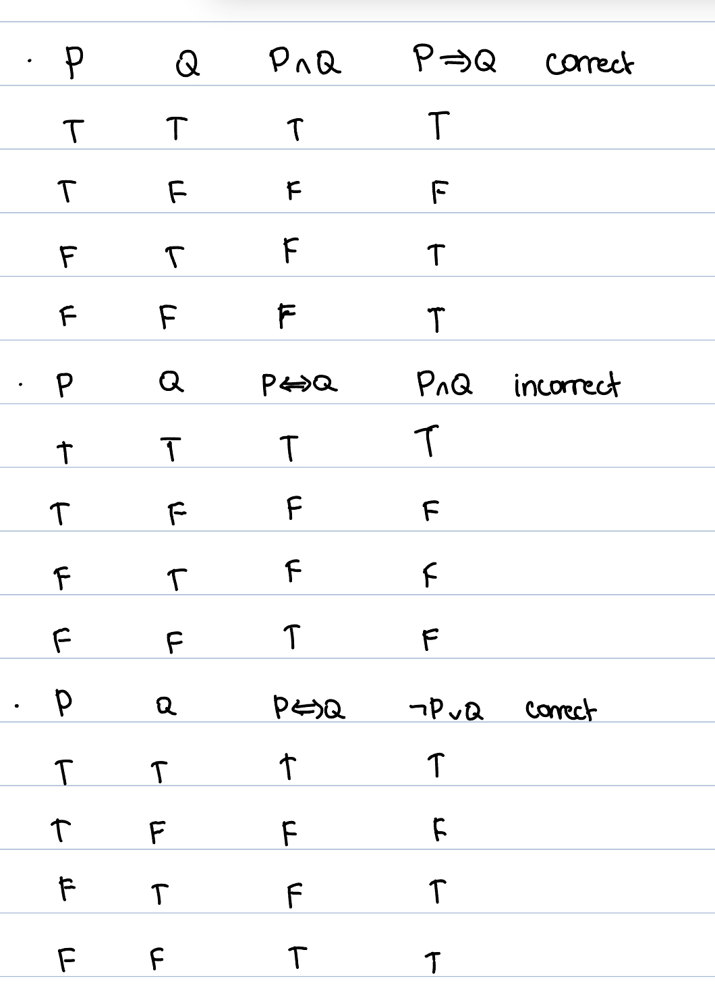

  - In any model m, ¬φ is true when φ is false. So, φ valid φ true in every m ¬φ true in no m ¬φ unsatisfiable. Be proving that not φ is unsatisfiable, we prove it is not in any cases in the knowledge base, therefore proving φ to be valid.
  - If KB is unsatisfiable, then M(KB) = the empty set. There is no model where KB is true and a is false.
  - Assume φ ⊧ ψ and take any model m. If φ is false in m, then ¬φ is true, so ¬φ ∨ ψ is true. If φ is true in m, then ψ is true by entailment, so ¬φ ∨ ψ is true. Either way it’s true in every m, so it’s valid. Also assume ¬φ ∨ ψ is valid and take any m where φ is true. Then ¬φ is false, so ψ must be true for the disjunction to hold. So M(φ) ⊆ M(ψ), which means φ ⊧ ψ.
  - By definition, φ ≡ ψ iff φ ⊧ ψ and ψ ⊧ φ. By #3, φ ⊧ ψ iff ¬φ ∨ ψ is valid, and ¬φ ∨ ψ ≡ φ ⇒ ψ. In the same way, ψ ⊧ φ iff ψ ⇒ φ is valid. Putting these together gives the result.
  - φ ⊧ ψ ⇔ ¬φ ∨ ψ is valid (by #3) ⇔ ¬(¬φ ∨ ψ) is unsatisfiable (by #1) ⇔ φ ∧ ¬ψ is unsatisfiable (by De Morgan and double negation).

Analysis - How resolution by refutation works
To show that KB ⊨ α, we prove that KB ∧ ¬α is unsatisfiable, meaning no truth assignment makes it true. We add ¬α to the KB in CNF and repeatedly apply the resolution rule. From two clauses that contain a complementary pair (L in one, ¬L in the other), the rule derives a new clause containing all the remaining literals of both.
Resolution is sound: anything it derives is entailed by the clauses it came from. So if it derives the empty clause (a contradiction), KB ∧ ¬α must be unsatisfiable, and KB ⊨ α. Resolution is also refutation-complete: if KB ∧ ¬α really is unsatisfiable, the empty clause can eventually be derived. If the procedure reaches a point where no new clauses can be generated and the empty clause was never found, no contradiction exists, and KB does not entail α. Propositional logic has only finitely many clauses over a fixed set of symbols, so this procedure always terminates.
Resolution step: my program counts one step each time resolve() is called on a distinct, unordered pair of clauses that share at least one complementary pair of literals. Pairs with nothing to cancel are not counted, and no pair is ever resolved twice.

Discussion of the test cases
Test 1 (Task 3 KB, query Z): True, 353 steps. D and C are facts, so (D ∧ C) ⇒ J gives J. Then (C ∧ J) ⇒ K gives K, (J ∧ K) ⇒ X gives X, and X ⇒ Z gives Z. Adding ¬Z contradicts this chain. The shortest refutation needs only 7 resolutions: ¬Z → ¬X → ¬J∨¬K → ¬C∨¬J → ¬J → ¬D∨¬C → ¬C → □. The program took 353 because it works breadth-first. It resolves every resolvable pair in each round, including the unused rule (D ∧ X) ⇒ J and many intermediate clauses that are never part of the proof. The clause set grew from 8 to 85 before the empty clause appeared.
Test 2 (proof by cases, query R): True, 13 steps. The KB is P ∨ Q, P ⇒ R, and Q ⇒ R. In every model either P or Q is true, and both imply R, so R holds in every model of the KB. Resolution finds this by deriving ¬P and ¬Q from ¬R, which then contradict P ∨ Q. This case shows that resolution handles disjunctive reasoning that simple forward chaining on known facts cannot.
Test 3 (missing rule, query R): False, 4 steps. Without Q ⇒ R, the assignment P = False, Q = True, R = False satisfies every clause of the KB together with ¬R. Because a satisfying assignment exists, no contradiction can be derived. The program generated Q ∨ R, ¬P, and Q, then found that every further resolvent was already present, so it correctly returned False. In a non-entailed case, every resolvable pair has to be tried before the program can stop. Here that was only 4 pairs.

One limitation
The main limitation is inefficiency from undirected, saturating search. The program resolves every pair of clauses in every round. It has no strategy for choosing which pairs are likely to lead toward the empty clause, so the number of clauses and pairs can grow very quickly. Test 1 shows this: 353 steps for a proof that needs 7. With larger knowledge bases, the number of pairs grows roughly quadratically with the number of clauses. The number of possible clauses grows exponentially with the number of symbols, so the procedure can become impractical well before it terminates.
Two strategies would help. Set-of-support only resolves pairs where at least one clause comes from the negated query or its descendants. Unit preference resolves single-literal clauses first. Removing clauses that are subsumed by shorter ones would also cut the search space. A related limitation is that the program assumes its input is already in CNF and accepts only a single symbol as the query. It cannot check whether a compound sentence like P ∧ Q is entailed without a CNF converter.

